**Exercise 1: Control Structures**

**Scenario 1:** The bank wants to apply a discount to loan interest rates for customers above 60 years old.

* + **Question:** Write a PL/SQL block that loops through all customers, checks their age, and if they are above 60, apply a 1% discount to their current loan interest rates.

**Code –**

UPDATE Loans

SET InterestRate = InterestRate - 0.01

WHERE CustomerID IN (

SELECT CustomerID

FROM Customers

WHERE FLOOR(MONTHS_BETWEEN(SYSDATE, DOB) / 12) > 60

);

--- SELECT EXTRACT(YEAR FROM SYSDATE) - EXTRACT(YEAR FROM DOB) AS age

--- FROM Customers;

UPDATE Loans

SET InterestRate = InterestRate - 0.01

WHERE CustomerID IN (

SELECT CustomerID

FROM Customers

WHERE EXTRACT(YEAR FROM SYSDATE) - EXTRACT(YEAR FROM DOB) > 60

);

**Output**

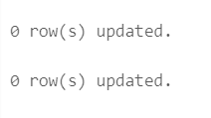

**Scenario 2:** A customer can be promoted to VIP status based on their balance.

* + **Question:** Write a PL/SQL block that iterates through all customers and sets a flag IsVIP to TRUE for those with a balance over $10,000.

**Code-**

ALTER TABLE Customers

ADD IsVIP NUMBER(1) DEFAULT 0;

BEGIN

FOR customer_record IN (

SELECT CustomerID, Balance

FROM Customers

) LOOP

IF customer_record.Balance > 10000 THEN

UPDATE Customers

SET IsVIP = 1

WHERE CustomerID = customer_record.CustomerID;

END IF;

END LOOP;

END;

/

SELECT * FROM CUSTOMERS;

**Output**

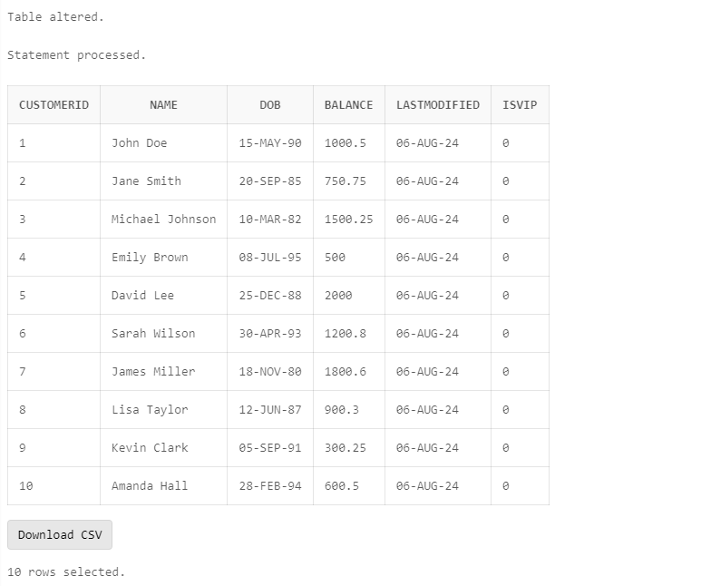

**Scenario 3:** The bank wants to send reminders to customers whose loans are due within the next 30 days.

* + **Question:** Write a PL/SQL block that fetches all loans due in the next 30 days and prints a reminder message for each customer.

**Code –**

SET SERVEROUTPUT ON;

BEGIN

DBMS_OUTPUT.PUT_LINE('Starting to fetch loan reminders...');

FOR loan_record IN (

SELECT l.LoanID, l.CustomerID, l.EndDate, c.Name

FROM Loans l

JOIN Customers c ON l.CustomerID = c.CustomerID

WHERE l.EndDate BETWEEN SYSDATE AND SYSDATE + 30

) LOOP

DBMS_OUTPUT.PUT_LINE('Reminder: Loan ID ' || loan_record.LoanID ||

' for customer ' || loan_record.Name ||

' (Customer ID: ' || loan_record.CustomerID || ') is due on ' ||

TO_CHAR(loan_record.EndDate, 'DD-MON-YYYY') || '.');

END LOOP;

DBMS_OUTPUT.PUT_LINE('Finished fetching loan reminders.');

END;

/

**Output –**

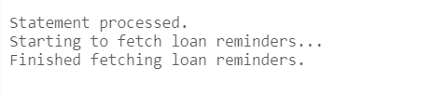

**Exercise 2: Error Handling**

**Scenario 1:** Handle exceptions during fund transfers between accounts.

* + **Question:** Write a stored procedure **SafeTransferFunds** that transfers funds between two accounts. Ensure that if any error occurs (e.g., insufficient funds), an appropriate error message is logged and the transaction is rolled back.

**Code-**

SET SERVEROUTPUT ON;

CREATE OR REPLACE PROCEDURE SafeTransferFunds (

p_from_account_id NUMBER,

p_to_account_id NUMBER,

p_amount NUMBER

) IS

insufficient_funds EXCEPTION;

v_from_account_balance NUMBER;

v_to_account_balance NUMBER;

v_error_message VARCHAR2(4000);

BEGIN

DBMS_OUTPUT.PUT_LINE('Starting Procedure');

SELECT balance INTO v_from_account_balance

FROM Accounts

WHERE AccountID = p_from_account_id

FOR UPDATE;

DBMS_OUTPUT.PUT_LINE('From Account Balance: ' || v_from_account_balance);

IF v_from_account_balance < p_amount THEN

RAISE insufficient_funds;

END IF;

SELECT balance INTO v_to_account_balance

FROM Accounts

WHERE AccountID = p_to_account_id

FOR UPDATE;

DBMS_OUTPUT.PUT_LINE('To Account Balance: ' || v_to_account_balance);

UPDATE Accounts

SET balance = balance - p_amount, LastModified = SYSDATE

WHERE AccountID = p_from_account_id;

UPDATE Accounts

SET balance = balance + p_amount, LastModified = SYSDATE

WHERE AccountID = p_to_account_id;

COMMIT;

DBMS_OUTPUT.PUT_LINE('Transaction Committed');

EXCEPTION

WHEN insufficient_funds THEN

DBMS_OUTPUT.PUT_LINE('Insufficient Funds Exception');

v_error_message := 'Insufficient funds in account ' || p_from_account_id;

---DBMS_OUTPUT.PUT_LINE('Logging error: ' || v_error_message);

---INSERT INTO error_log (error_id, error_message, log_date)

---VALUES (error_log_seq.NEXTVAL, v_error_message, SYSDATE);

--DBMS_OUTPUT.PUT_LINE('Error logged successfully');

ROLLBACK;

WHEN OTHERS THEN

v_error_message := SQLERRM;

DBMS_OUTPUT.PUT_LINE('Other Exception: ' || v_error_message);

---DBMS_OUTPUT.PUT_LINE('Logging error: ' || v_error_message);

---INSERT INTO error_log (error_id, error_message, log_date)

---VALUES (error_log_seq.NEXTVAL, v_error_message, SYSDATE);

--DBMS_OUTPUT.PUT_LINE('Error logged successfully');

ROLLBACK;

END SafeTransferFunds;

/

INSERT INTO Customers (CustomerID, Name, DOB, Balance, LastModified)

VALUES (20, 'John Doe', TO_DATE('1990-01-01', 'YYYY-MM-DD'), 20000, SYSDATE);

INSERT INTO Customers (CustomerID, Name, DOB, Balance, LastModified)

VALUES (21, 'Jane Smith', TO_DATE('1995-05-15', 'YYYY-MM-DD'), 30000, SYSDATE);

INSERT INTO Accounts (AccountID, CustomerID, AccountType, Balance, LastModified)

VALUES (20, 20, 'Checking', 10000, SYSDATE);

INSERT INTO Accounts (AccountID, CustomerID, AccountType, Balance, LastModified)

VALUES (21, 21, 'Savings', 5000, SYSDATE);

COMMIT;

SELECT * FROM ACCOUNTS;

EXEC SafeTransferFunds(20, 21, 1000);

EXEC SafeTransferFunds(20, 21, 20000);

SELECT * FROM error_log;

**OUTPUT**

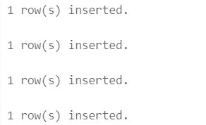

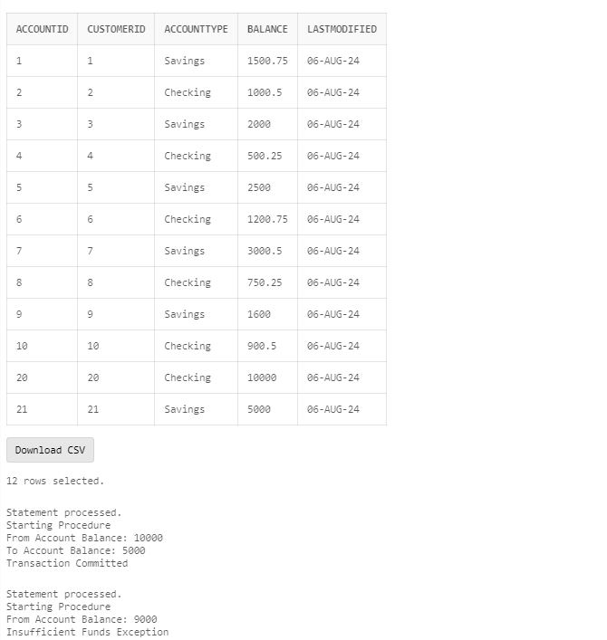

**Scenario 2:** Manage errors when updating employee salaries.

* + **Question:** Write a stored procedure **UpdateSalary** that increases the salary of an employee by a given percentage. If the employee ID does not exist, handle the exception and log an error message.

**Code –**

CREATE OR REPLACE PROCEDURE UpdateSalary (

p_EmployeeID IN Employees.EmployeeID%TYPE,

p_Percentage IN NUMBER

) IS

v_OldSalary Employees.Salary%TYPE;

BEGIN

SELECT Salary

INTO v_OldSalary

FROM Employees

WHERE EmployeeID = p_EmployeeID;

UPDATE Employees

SET Salary = Salary * (1 + p_Percentage / 100)

WHERE EmployeeID = p_EmployeeID;

COMMIT;

DBMS_OUTPUT.PUT_LINE('Salary updated successfully.');

EXCEPTION

WHEN NO_DATA_FOUND THEN

DBMS_OUTPUT.PUT_LINE('Error: Employee with ID ' || p_EmployeeID || ' does not exist.');

WHEN OTHERS THEN

DBMS_OUTPUT.PUT_LINE('Error: ' || SQLERRM);

END UpdateSalary;

/

BEGIN

UpdateSalary(p_EmployeeID => 1, p_Percentage => 10);

END;

/

BEGIN

UpdateSalary(123,10);

END;

/

**OUTPUT –**

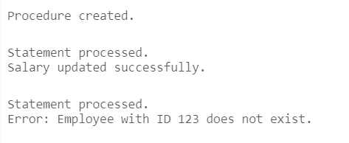

**Scenario 3:** Ensure data integrity when adding a new customer.

* + **Question:** Write a stored procedure **AddNewCustomer** that inserts a new customer into the Customers table. If a customer with the same ID already exists, handle the exception by logging an error and preventing the insertion.

**Code –**

CREATE OR REPLACE PROCEDURE AddNewCustomer (

p_CustomerID IN Customers.CustomerID%TYPE,

p_Name IN Customers.Name%TYPE,

p_DOB IN Customers.DOB%TYPE,

p_Balance IN Customers.Balance%TYPE,

p_LastModified IN Customers.LastModified%TYPE

) IS

BEGIN

BEGIN

INSERT INTO Customers (CustomerID, Name, DOB, Balance, LastModified)

VALUES (p_CustomerID, p_Name, p_DOB, p_Balance, p_LastModified);

COMMIT;

DBMS_OUTPUT.PUT_LINE('Customer added successfully.');

EXCEPTION

WHEN DUP_VAL_ON_INDEX THEN

DBMS_OUTPUT.PUT_LINE('Error: Customer with ID ' || p_CustomerID || ' already exists.');

WHEN OTHERS THEN

DBMS_OUTPUT.PUT_LINE('Error: ' || SQLERRM);

END;

END AddNewCustomer;

/

BEGIN

AddNewCustomer(

p_CustomerID => 1001,

p_Name => 'John Doe',

p_DOB => TO_DATE('1980-01-15', 'YYYY-MM-DD'),

p_Balance => 5000,

p_LastModified => SYSDATE

);

END;

/

BEGIN

AddNewCustomer(

p_CustomerID => 1002,

p_Name => 'Johnnnnn Doe',

p_DOB => TO_DATE('1980-01-15', 'YYYY-MM-DD'),

p_Balance => 500053,

p_LastModified => SYSDATE

);

END;

/

BEGIN

AddNewCustomer(

p_CustomerID => 1001,

p_Name => 'Johnyyy Doe',

p_DOB => TO_DATE('1980-01-15', 'YYYY-MM-DD'),

p_Balance => 503300,

p_LastModified => SYSDATE

);

END;

/

**OUTPUT-**

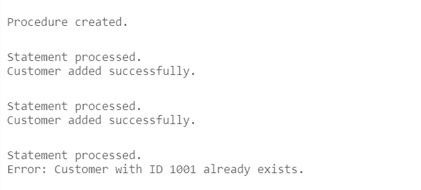

**Exercise 3: Stored Procedures**

**Scenario 1:** The bank needs to process monthly interest for all savings accounts.

* + **Question:** Write a stored procedure **ProcessMonthlyInterest** that calculates and updates the balance of all savings accounts by applying an interest rate of 1% to the current balance.

**Code –**

CREATE OR REPLACE PROCEDURE ProcessMonthlyInterest (

p_InterestRate IN NUMBER

) IS

BEGIN

UPDATE Account

SET Balance = Balance * (1 + p_InterestRate / 100)

WHERE AccountType = 'Savings';

COMMIT;

DBMS_OUTPUT.PUT_LINE('Monthly interest applied to all savings Account with an interest rate of ' || p_InterestRate || '%.');

EXCEPTION

WHEN OTHERS THEN

DBMS_OUTPUT.PUT_LINE('Error: ' || SQLERRM);

ROLLBACK;

END ProcessMonthlyInterest;

/

BEGIN

ProcessMonthlyInterest(p_InterestRate => 1);

END;

/

SELECT * FROM Account;

**OUTPUT –**

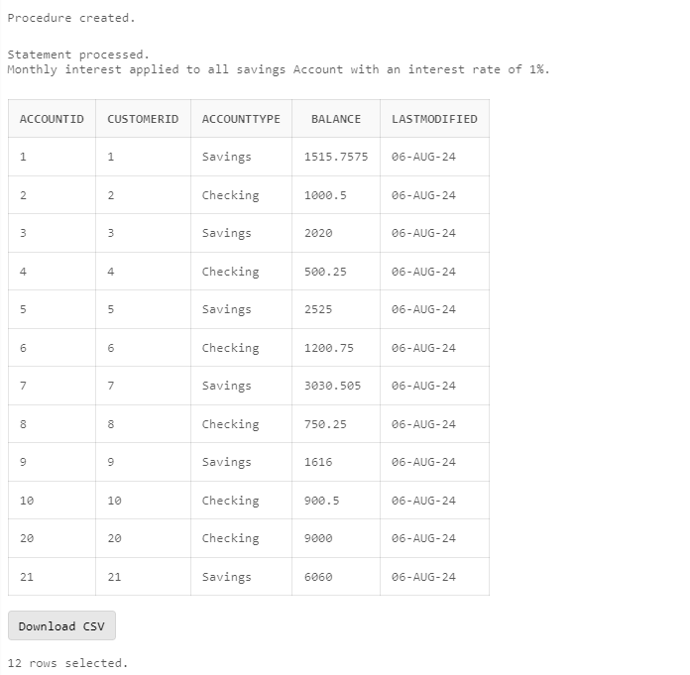

**Scenario 2:** The bank wants to implement a bonus scheme for employees based on their performance.

* + **Question:** Write a stored procedure **UpdateEmployeeBonus** that updates the salary of employees in a given department by adding a bonus percentage passed as a parameter.

**Code –**

CREATE OR REPLACE PROCEDURE UpdateEmployeeBonus (

p_Department IN Employees.Department%TYPE,

p_BonusPercentage IN NUMBER

) IS

BEGIN

UPDATE Employees

SET Salary = Salary * (1 + p_BonusPercentage / 100)

WHERE Department = p_Department;

COMMIT;

DBMS_OUTPUT.PUT_LINE('Salaries updated with a bonus of ' || p_BonusPercentage || '% for department ' || p_Department || '.');

EXCEPTION

WHEN OTHERS THEN

DBMS_OUTPUT.PUT_LINE('Error: ' || SQLERRM);

ROLLBACK;

END UpdateEmployeeBonus;

/

SELECT * FROM EMPLOYEES;

BEGIN

UpdateEmployeeBonus(p_Department => 'Sales', p_BonusPercentage => 10);

END;

/

SELECT * FROM EMPLOYEES;

**OUTPUT –**

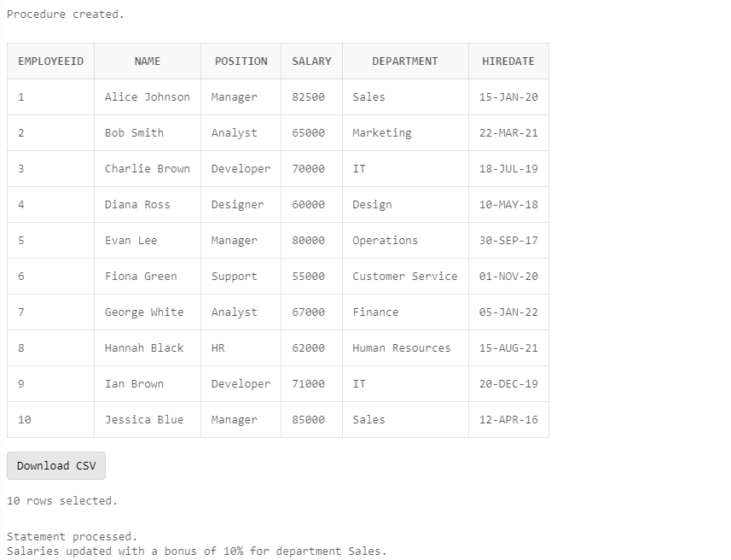

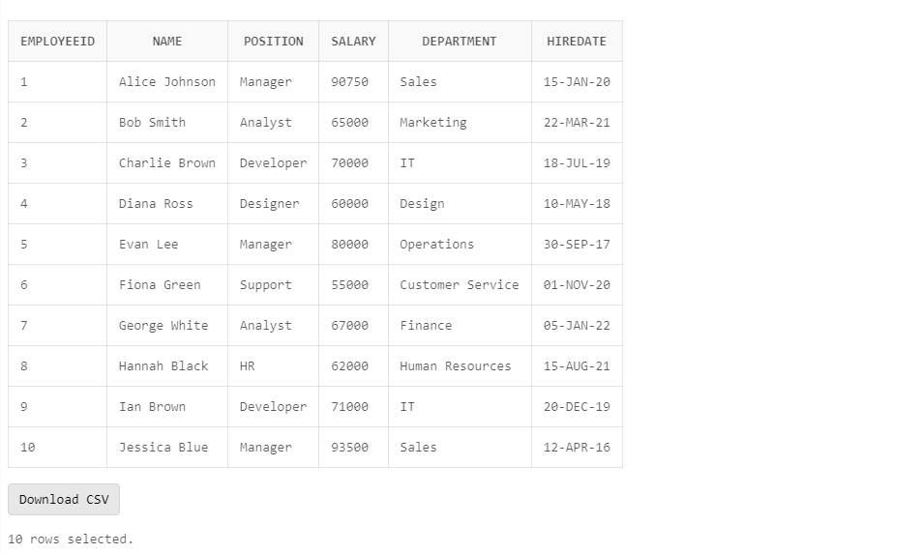

**Scenario 3:** Customers should be able to transfer funds between their accounts.

* + **Question:** Write a stored procedure **TransferFunds** that transfers a specified amount from one account to another, checking that the source account has sufficient balance before making the transfer.

**Code –**

CREATE OR REPLACE PROCEDURE TransferFunds (

p_SourceAccountID IN Account.AccountID%TYPE,

p_DestinationAccountID IN Account.AccountID%TYPE,

p_Amount IN NUMBER

) IS

v_SourceBalance Account.Balance%TYPE;

BEGIN

SELECT Balance INTO v_SourceBalance

FROM Account

WHERE AccountID = p_SourceAccountID;

IF v_SourceBalance < p_Amount THEN

RAISE_APPLICATION_ERROR(-20001, 'Insufficient balance in source account.');

END IF;

BEGIN

UPDATE Account

SET Balance = Balance - p_Amount

WHERE AccountID = p_SourceAccountID;

UPDATE Account

SET Balance = Balance + p_Amount

WHERE AccountID = p_DestinationAccountID;

COMMIT;

DBMS_OUTPUT.PUT_LINE('Funds transferred successfully.');

EXCEPTION

WHEN OTHERS THEN

DBMS_OUTPUT.PUT_LINE('Error: ' || SQLERRM);

ROLLBACK; -- Rollback the transaction in case of an error

END;

END TransferFunds;

/

BEGIN

TransferFunds(p_SourceAccountID => 1, p_DestinationAccountID => 2, p_Amount => 500);

END;

/

BEGIN

TransferFunds(p_SourceAccountID => 1, p_DestinationAccountID => 2, p_Amount => 50000000000);

END;

/

**OUTPUT –**

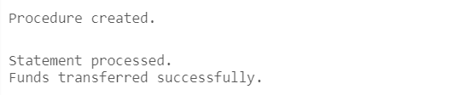

**Exercise 4: Functions**

**Scenario 1:** Calculate the age of customers for eligibility checks.

* + **Question:** Write a function CalculateAge that takes a customer's date of birth as input and returns their age in years.

**Code –**

CREATE OR REPLACE FUNCTION CalculateAge (

p_DOB IN DATE

) RETURN NUMBER IS

v_Age NUMBER;

BEGIN

SELECT FLOOR(MONTHS_BETWEEN(SYSDATE, p_DOB) / 12)

INTO v_Age

FROM dual;

RETURN v_Age;

EXCEPTION

WHEN OTHERS THEN

DBMS_OUTPUT.PUT_LINE('Error: ' || SQLERRM);

RETURN NULL; -- Return NULL in case of an error

END CalculateAge;

/

DECLARE

v_Age NUMBER;

BEGIN

v_Age := CalculateAge(TO_DATE('1980-01-15', 'YYYY-MM-DD'));

DBMS_OUTPUT.PUT_LINE('The age is: ' || v_Age);

END;

/

**OUTPUT –**

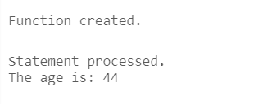

**Scenario 2:** The bank needs to compute the monthly installment for a loan.

* + **Question:** Write a function **CalculateMonthlyInstallment** that takes the loan amount, interest rate, and loan duration in years as input and returns the monthly installment amount.

**Code –**

CREATE OR REPLACE FUNCTION CalculateMonthlyInstallment (

p_LoanAmount IN NUMBER,

p_InterestRate IN NUMBER,

p_LoanDurationYears IN NUMBER

) RETURN NUMBER IS

v_MonthlyInstallment NUMBER;

v_MonthlyInterestRate NUMBER;

v_NumPayments NUMBER;

BEGIN

v_MonthlyInterestRate := p_InterestRate / 12 / 100;

v_NumPayments := p_LoanDurationYears * 12;

IF v_MonthlyInterestRate > 0 THEN

v_MonthlyInstallment := (p_LoanAmount * v_MonthlyInterestRate) /

(1 - POWER(1 + v_MonthlyInterestRate, -v_NumPayments));

ELSE

-- If interest rate is 0, simply divide loan amount by number of payments

v_MonthlyInstallment := p_LoanAmount / v_NumPayments;

END IF;

RETURN v_MonthlyInstallment;

END CalculateMonthlyInstallment;

/

DECLARE

v_MonthlyInstallment NUMBER;

BEGIN

v_MonthlyInstallment := CalculateMonthlyInstallment(

p_LoanAmount => 10000,

p_InterestRate => 5,

p_LoanDurationYears => 10

);

DBMS_OUTPUT.PUT_LINE('The monthly installment is: ' || v_MonthlyInstallment);

END;

/

**OUTPUT –**

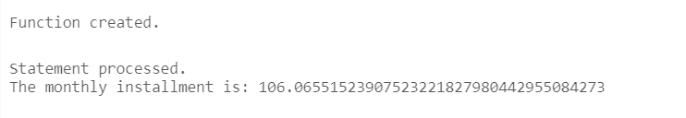

**Scenario 3:** Check if a customer has sufficient balance before making a transaction.

* + **Question:** Write a function **HasSufficientBalance** that takes an account ID and an amount as input and returns a boolean indicating whether the account has at least the specified amount.

**Code –**

CREATE OR REPLACE FUNCTION HasSufficientBalance (

p_AccountID IN Account.AccountID%TYPE,

p_Amount IN NUMBER

) RETURN BOOLEAN IS

v_Balance NUMBER;

BEGIN

SELECT Balance INTO v_Balance

FROM Account

WHERE AccountID = p_AccountID;

IF v_Balance >= p_Amount THEN

RETURN TRUE;

ELSE

RETURN FALSE;

END IF;

EXCEPTION

WHEN NO_DATA_FOUND THEN

RETURN FALSE;

WHEN OTHERS THEN

DBMS_OUTPUT.PUT_LINE('Error: ' || SQLERRM);

RETURN FALSE;

END HasSufficientBalance;

/

DECLARE

v_HasSufficient BOOLEAN;

BEGIN

v_HasSufficient := HasSufficientBalance(p_AccountID => 222, p_Amount => 500);

IF v_HasSufficient THEN

DBMS_OUTPUT.PUT_LINE('The account has sufficient balance.');

ELSE

DBMS_OUTPUT.PUT_LINE('The account does not have sufficient balance.');

END IF;

END;

/

**OUTPUT –**

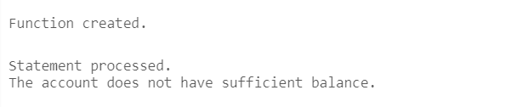

**Exercise 5: Triggers**

**Scenario 1:** Automatically update the last modified date when a customer's record is updated.

* + **Question:** Write a trigger **UpdateCustomerLastModified** that updates the LastModified column of the Customers table to the current date whenever a customer's record is updated.

**Code –**

CREATE OR REPLACE TRIGGER UpdateCustomerLastModified

BEFORE UPDATE ON Customers

FOR EACH ROW

BEGIN

:NEW.LastModified := SYSDATE;

END;

/

UPDATE Customers

SET Name = 'John Doe'

WHERE CustomerID = 1;

SELECT * FROM CUSTOMERS;

**OUTPUT –**

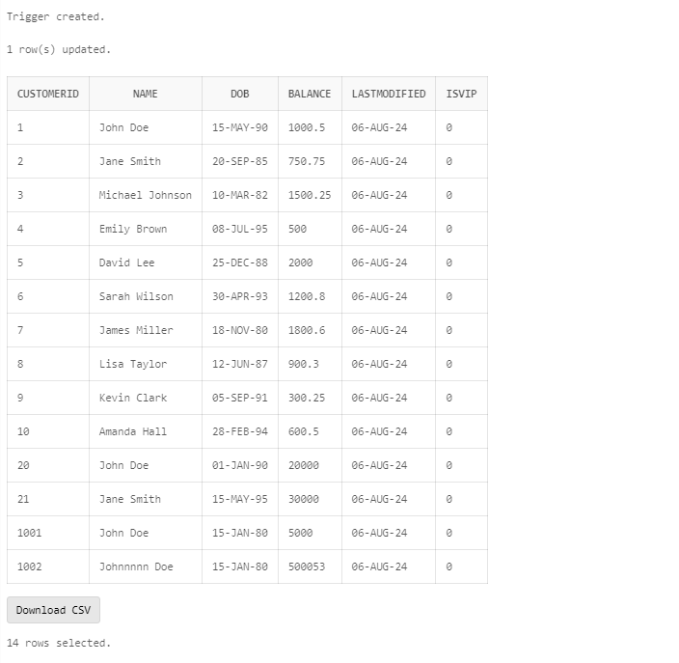

**Scenario 2:** Maintain an audit log for all transactions.

* + **Question:** Write a trigger **LogTransaction** that inserts a record into an AuditLog table whenever a transaction is inserted into the Transactions table.

**Code –**

CREATE TABLE AuditLog (

TransactionID NUMBER PRIMARY KEY,

AuditDate DATE,

Action VARCHAR2(50),

FOREIGN KEY (TransactionID) REFERENCES Transactions(TransactionID)

);

CREATE OR REPLACE TRIGGER LogTransaction

AFTER INSERT ON Transactions

FOR EACH ROW

BEGIN

INSERT INTO AuditLog (TransactionID, AuditDate, Action)

VALUES (

:NEW.TransactionID,

SYSDATE,

'INSERT'

);

END;

/

INSERT INTO Transactions (TransactionID, AccountID, TransactionDate, Amount, TransactionType) VALUES (11, 8, TO_DATE('2024-07-28', 'YYYY-MM-DD'), 500.00, 'Withdrawal');

SELECT * FROM AuditLog;

**OUTPUT –**

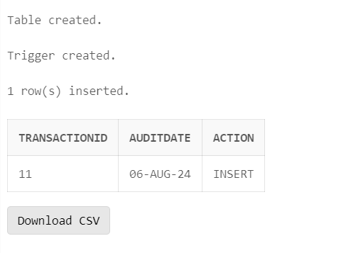

**Scenario 3:** Enforce business rules on deposits and withdrawals.

* + **Question:** Write a trigger **CheckTransactionRules** that ensures withdrawals do not exceed the balance and deposits are positive before inserting a record into the Transactions table.

**Code –**

CREATE OR REPLACE TRIGGER CheckTransactionRules

BEFORE INSERT ON Transactions

FOR EACH ROW

DECLARE

v_balance NUMBER;

BEGIN

SELECT Balance INTO v_balance

FROM Account

WHERE AccountID = :NEW.AccountID;

IF :NEW.TransactionType = 'Withdrawal' THEN

IF :NEW.Amount > v_balance THEN

RAISE_APPLICATION_ERROR(-20001, 'Withdrawal amount exceeds the current balance.');

END IF;

ELSIF :NEW.TransactionType = 'Deposit' THEN

IF :NEW.Amount <= 0 THEN

RAISE_APPLICATION_ERROR(-20002, 'Deposit amount must be positive.');

END IF;

ELSE

RAISE_APPLICATION_ERROR(-20003, 'Invalid transaction type. Must be DEPOSIT or WITHDRAWAL.');

END IF;

END;

/

INSERT INTO Transactions (TransactionID, AccountID, TransactionDate, Amount, TransactionType) VALUES (11, 5, TO_DATE('2024-07-20', 'YYYY-MM-DD'), 500999999.00, 'WITHDRAWAL')

**OUTPUT –**



**Exercise 6: Cursors**

**Scenario 1:** Generate monthly statements for all customers.

* + **Question:** Write a PL/SQL block using an explicit cursor **GenerateMonthlyStatements** that retrieves all transactions for the current month and prints a statement for each customer.

**Code –**

DECLARE

CURSOR GenerateMonthlyStatements IS

SELECT t.TransactionID, t.AccountID, t.TransactionDate, t.Amount, t.TransactionType

FROM Transactions t

JOIN Account a ON t.AccountID = a.AccountID

WHERE EXTRACT(MONTH FROM t.TransactionDate) = EXTRACT(MONTH FROM SYSDATE)

AND EXTRACT(YEAR FROM t.TransactionDate) = EXTRACT(YEAR FROM SYSDATE);

v_Transaction GenerateMonthlyStatements%ROWTYPE;

--v_Transaction TransactionRec;

BEGIN

OPEN GenerateMonthlyStatements;

LOOP

FETCH GenerateMonthlyStatements INTO v_Transaction;

EXIT WHEN GenerateMonthlyStatements%NOTFOUND;

DBMS_OUTPUT.PUT_LINE('Transaction ID: ' || v_Transaction.TransactionID);

DBMS_OUTPUT.PUT_LINE('Account ID: ' || v_Transaction.AccountID);

DBMS_OUTPUT.PUT_LINE('Transaction Date: ' || v_Transaction.TransactionDate);

DBMS_OUTPUT.PUT_LINE('Amount: ' || v_Transaction.Amount);

DBMS_OUTPUT.PUT_LINE('Transaction Type: ' || v_Transaction.TransactionType);

DBMS_OUTPUT.PUT_LINE('-----------------------------------');

END LOOP;

CLOSE GenerateMonthlyStatements;

EXCEPTION

WHEN OTHERS THEN

DBMS_OUTPUT.PUT_LINE('Error: ' || SQLERRM);

END;

/

INSERT INTO Transactions (TransactionID, AccountID, TransactionDate, Amount, TransactionType)

VALUES (15, 1, TO_DATE('2024-08-01', 'YYYY-MM-DD'), 1000, 'DEPOSIT');

INSERT INTO Transactions (TransactionID, AccountID, TransactionDate, Amount, TransactionType)

VALUES (16, 2, TO_DATE('2024-08-15', 'YYYY-MM-DD'), 500, 'WITHDRAWAL');

INSERT INTO Transactions (TransactionID, AccountID, TransactionDate, Amount, TransactionType)

VALUES (17, 3, TO_DATE('2024-08-20', 'YYYY-MM-DD'), 1500, 'DEPOSIT');

INSERT INTO Transactions (TransactionID, AccountID, TransactionDate, Amount, TransactionType)

VALUES (18, 4, TO_DATE('2024-07-25', 'YYYY-MM-DD'), 2000, 'DEPOSIT'); -- Older transaction

COMMIT;

**OUTPUT –**



**Scenario 2:** Apply annual fee to all accounts.

* + **Question:** Write a PL/SQL block using an explicit cursor **ApplyAnnualFee** that deducts an annual maintenance fee from the balance of all accounts.

**Code –**

DECLARE

CURSOR ApplyAnnualFee IS

SELECT AccountID, Balance

FROM Account;

v_Account ApplyAnnualFee%ROWTYPE;

v_AnnualFee NUMBER := 100;

BEGIN

OPEN ApplyAnnualFee;

LOOP

FETCH ApplyAnnualFee INTO v_Account;

EXIT WHEN ApplyAnnualFee%NOTFOUND;

IF v_Account.Balance >= v_AnnualFee THEN

UPDATE Account

SET Balance = Balance - v_AnnualFee

WHERE AccountID = v_Account.AccountID;

ELSE

DBMS_OUTPUT.PUT_LINE('Insufficient balance for Account ID: ' || v_Account.AccountID);

END IF;

END LOOP;

CLOSE ApplyAnnualFee;

COMMIT;

EXCEPTION

WHEN OTHERS THEN

DBMS_OUTPUT.PUT_LINE('Error: ' || SQLERRM);

END;

/

SELECT * FROM Account;

**OUTPUT –**



**Scenario 3:** Update the interest rate for all loans based on a new policy.

* + **Question:** Write a PL/SQL block using an explicit cursor **UpdateLoanInterestRates** that fetches all loans and updates their interest rates based on the new policy.

**Code –**

DECLARE

CURSOR UpdateLoanInterestRates IS

SELECT LoanID, InterestRate

FROM Loans;

v_Loan UpdateLoanInterestRates%ROWTYPE;

v_NewInterestRate NUMBER := 0.5;

BEGIN

OPEN UpdateLoanInterestRates;

LOOP

FETCH UpdateLoanInterestRates INTO v_Loan;

EXIT WHEN UpdateLoanInterestRates%NOTFOUND;

UPDATE Loans

SET InterestRate = InterestRate + v_NewInterestRate

WHERE LoanID = v_Loan.LoanID;

DBMS_OUTPUT.PUT_LINE('Updated Loan ID: ' || v_Loan.LoanID ||

', New Interest Rate: ' || (v_Loan.InterestRate + v_NewInterestRate));

END LOOP;

CLOSE UpdateLoanInterestRates;

COMMIT;

EXCEPTION

WHEN OTHERS THEN

-- Handle any exceptions that occur

DBMS_OUTPUT.PUT_LINE('Error: ' || SQLERRM);

END;

/

**OUTPUT –**

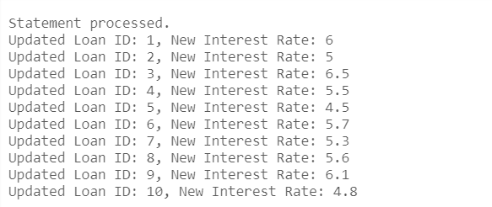

**Exercise 7: Packages**

**Scenario 1:** Group all customer-related procedures and functions into a package.

* + **Question:** Create a package **CustomerManagement** with procedures for adding a new customer, updating customer details, and a function to get customer balance.

**Code –**

CREATE OR REPLACE PACKAGE CustomerManagement AS

PROCEDURE AddNewCustomer(p_CustomerID IN NUMBER, p_Name IN VARCHAR2, p_DOB IN DATE, p_Balance IN NUMBER);

PROCEDURE UpdateCustomerDetails(p_CustomerID IN NUMBER, p_Name IN VARCHAR2, p_Balance IN NUMBER);

FUNCTION GetCustomerBalance(p_CustomerID IN NUMBER) RETURN NUMBER;

END CustomerManagement;

/

CREATE OR REPLACE PACKAGE BODY CustomerManagement AS

PROCEDURE AddNewCustomer(p_CustomerID IN NUMBER, p_Name IN VARCHAR2, p_DOB IN DATE, p_Balance IN NUMBER) IS

BEGIN

BEGIN

INSERT INTO Customers (CustomerID, Name, DOB, Balance, LastModified)

VALUES (p_CustomerID, p_Name, p_DOB, p_Balance, SYSDATE);

COMMIT;

EXCEPTION

WHEN DUP_VAL_ON_INDEX THEN

DBMS_OUTPUT.PUT_LINE('Customer with ID ' || p_CustomerID || ' already exists.');

WHEN OTHERS THEN

DBMS_OUTPUT.PUT_LINE('Error: ' || SQLERRM);

END;

END AddNewCustomer;

PROCEDURE UpdateCustomerDetails(p_CustomerID IN NUMBER, p_Name IN VARCHAR2, p_Balance IN NUMBER) IS

BEGIN

BEGIN

UPDATE Customers

SET Name = p_Name, Balance = p_Balance, LastModified = SYSDATE

WHERE CustomerID = p_CustomerID;

IF SQL%ROWCOUNT = 0 THEN

DBMS_OUTPUT.PUT_LINE('Customer with ID ' || p_CustomerID || ' does not exist.');

ELSE

COMMIT;

END IF;

EXCEPTION

WHEN OTHERS THEN

DBMS_OUTPUT.PUT_LINE('Error: ' || SQLERRM);

END;

END UpdateCustomerDetails;

FUNCTION GetCustomerBalance(p_CustomerID IN NUMBER) RETURN NUMBER IS

v_Balance NUMBER;

BEGIN

BEGIN

SELECT Balance INTO v_Balance

FROM Customers

WHERE CustomerID = p_CustomerID;

RETURN v_Balance;

EXCEPTION

WHEN NO_DATA_FOUND THEN

DBMS_OUTPUT.PUT_LINE('Customer with ID ' || p_CustomerID || ' does not exist.');

RETURN NULL;

WHEN OTHERS THEN

DBMS_OUTPUT.PUT_LINE('Error: ' || SQLERRM);

RETURN NULL;

END;

END GetCustomerBalance;

END CustomerManagement;

/

BEGIN

CustomerManagement.AddNewCustomer(

p_CustomerID => 123,

p_Name => 'Johnyyyy Doeeeeee',

p_DOB => TO_DATE('1990-01-01', 'YYYY-MM-DD'),

p_Balance => 10002

);

END;

/

SELECT * FROM CUSTOMERS;

BEGIN

CustomerManagement.UpdateCustomerDetails(

p_CustomerID => 123,

p_Name => 'John Doe Updated',

p_Balance => 15002

);

END;

/

SELECT * FROM CUSTOMERS;

DECLARE

v_Balance NUMBER;

BEGIN

v_Balance := CustomerManagement.GetCustomerBalance(p_CustomerID => 123);

DBMS_OUTPUT.PUT_LINE('Customer Balance: ' || v_Balance);

END;

/

**OUTPUT –**

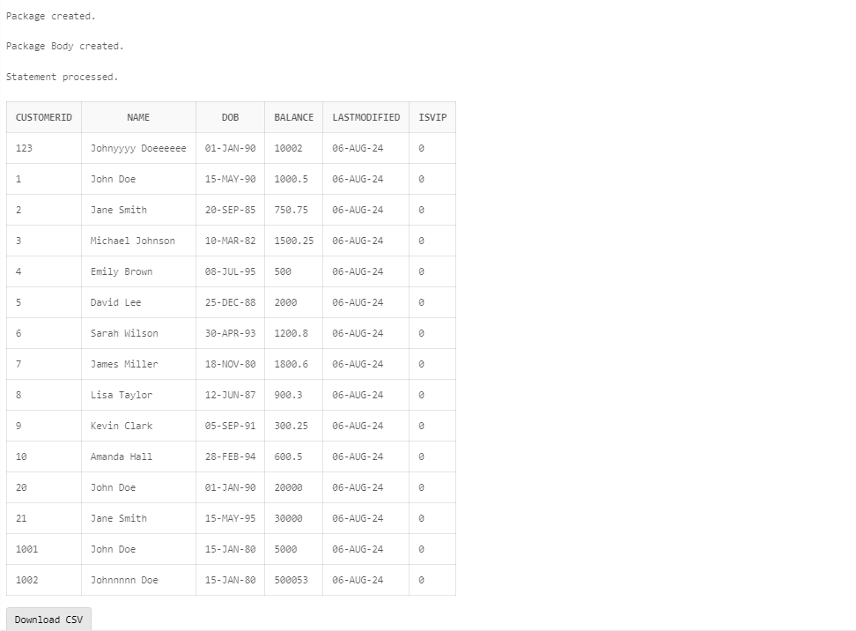

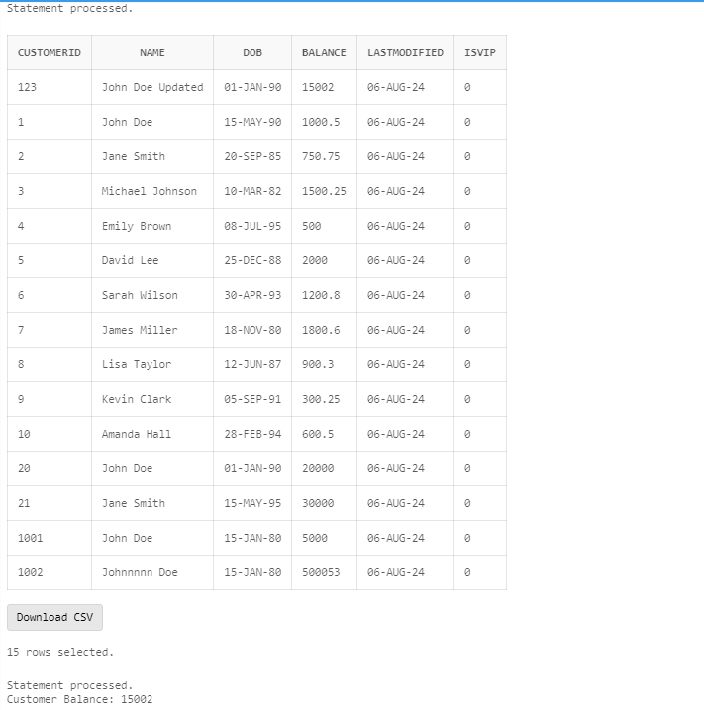

**Scenario 2:** Create a package to manage employee data.

* + **Question:** Write a package **EmployeeManagement** with procedures to hire new employees, update employee details, and a function to calculate annual salary.

**Code –**

CREATE OR REPLACE PACKAGE EmployeeManagement AS

PROCEDURE HireNewEmployee(p_EmployeeID IN NUMBER, p_Name IN VARCHAR2, p_Position IN VARCHAR2, p_Salary IN NUMBER, p_Department IN VARCHAR2);

PROCEDURE UpdateEmployeeDetails(p_EmployeeID IN NUMBER, p_Name IN VARCHAR2, p_Position IN VARCHAR2, p_Salary IN NUMBER, p_Department IN VARCHAR2);

FUNCTION CalculateAnnualSalary(p_EmployeeID IN NUMBER) RETURN NUMBER;

END EmployeeManagement;

/

CREATE OR REPLACE PACKAGE BODY EmployeeManagement AS

PROCEDURE HireNewEmployee(p_EmployeeID IN NUMBER, p_Name IN VARCHAR2, p_Position IN VARCHAR2, p_Salary IN NUMBER, p_Department IN VARCHAR2) IS

BEGIN

BEGIN

INSERT INTO Employees (EmployeeID, Name, Position, Salary, Department, HireDate)

VALUES (p_EmployeeID, p_Name, p_Position, p_Salary, p_Department, SYSDATE);

COMMIT;

EXCEPTION

WHEN DUP_VAL_ON_INDEX THEN

DBMS_OUTPUT.PUT_LINE('Employee with ID ' || p_EmployeeID || ' already exists.');

WHEN OTHERS THEN

DBMS_OUTPUT.PUT_LINE('Error: ' || SQLERRM);

END;

END HireNewEmployee;

PROCEDURE UpdateEmployeeDetails(p_EmployeeID IN NUMBER, p_Name IN VARCHAR2, p_Position IN VARCHAR2, p_Salary IN NUMBER, p_Department IN VARCHAR2) IS

BEGIN

BEGIN

UPDATE Employees

SET Name = p_Name, Position = p_Position, Salary = p_Salary, Department = p_Department

WHERE EmployeeID = p_EmployeeID;

IF SQL%ROWCOUNT = 0 THEN

DBMS_OUTPUT.PUT_LINE('Employee with ID ' || p_EmployeeID || ' does not exist.');

ELSE

COMMIT;

END IF;

EXCEPTION

WHEN OTHERS THEN

DBMS_OUTPUT.PUT_LINE('Error: ' || SQLERRM);

END;

END UpdateEmployeeDetails;

FUNCTION CalculateAnnualSalary(p_EmployeeID IN NUMBER) RETURN NUMBER IS

v_Salary NUMBER;

v_AnnualSalary NUMBER;

BEGIN

BEGIN

SELECT Salary INTO v_Salary

FROM Employees

WHERE EmployeeID = p_EmployeeID;

v_AnnualSalary := v_Salary * 12;

RETURN v_AnnualSalary;

EXCEPTION

WHEN NO_DATA_FOUND THEN

DBMS_OUTPUT.PUT_LINE('Employee with ID ' || p_EmployeeID || ' does not exist.');

RETURN NULL;

WHEN OTHERS THEN

DBMS_OUTPUT.PUT_LINE('Error: ' || SQLERRM);

RETURN NULL;

END;

END CalculateAnnualSalary;

END EmployeeManagement;

/

BEGIN

EmployeeManagement.HireNewEmployee(

p_EmployeeID => 101,

p_Name => 'Alice Smith',

p_Position => 'Software Engineer',

p_Salary => 5000,

p_Department => 'IT'

);

END;

/

SELECT * FROM EMPLOYEES;

BEGIN

EmployeeManagement.UpdateEmployeeDetails(

p_EmployeeID => 101,

p_Name => 'Alice Johnson',

p_Position => 'Senior Software Engineer',

p_Salary => 6000,

p_Department => 'IT'

);

END;

/

SELECT * FROM EMPLOYEES;

DECLARE

v_AnnualSalary NUMBER;

BEGIN

v_AnnualSalary := EmployeeManagement.CalculateAnnualSalary(p_EmployeeID => 101);

DBMS_OUTPUT.PUT_LINE('Annual Salary: ' || v_AnnualSalary);

END;

/

**OUTPUT –**

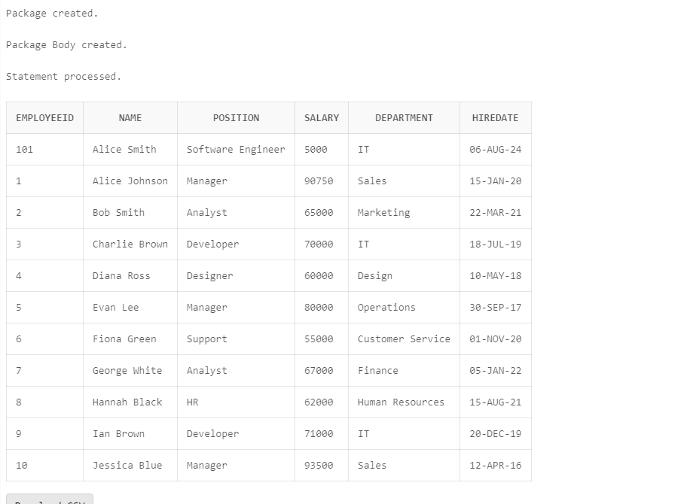

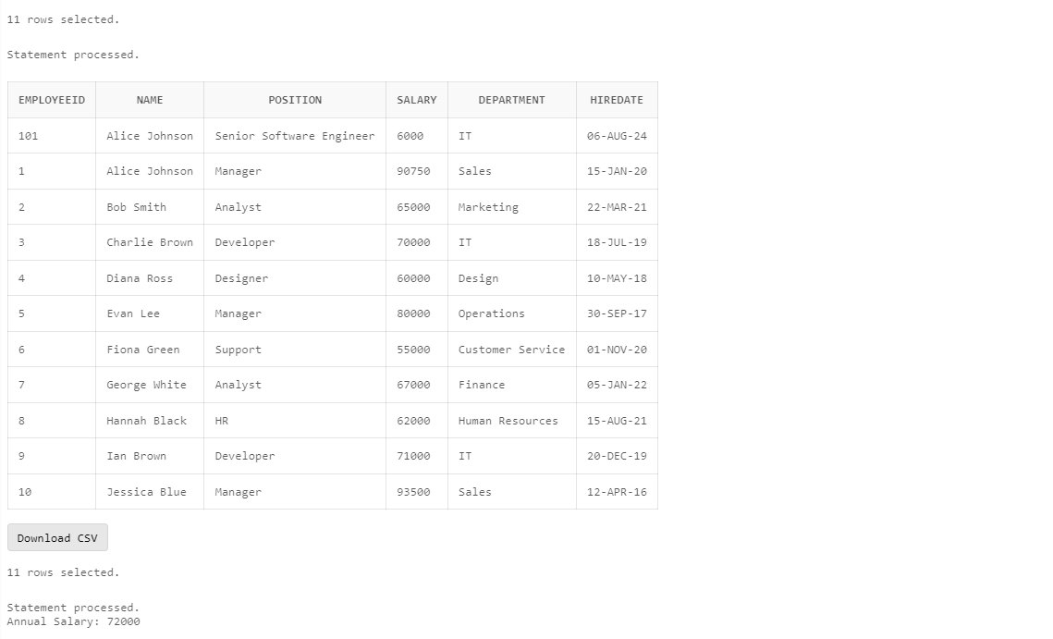

**Scenario 3:** Group all account-related operations into a package.

* + **Question:** Create a package **AccountOperations** with procedures for opening a new account, closing an account, and a function to get the total balance of a customer across all accounts.

**Code –**

CREATE OR REPLACE PACKAGE AccountOperations AS

PROCEDURE OpenNewAccount(p_AccountID IN NUMBER, p_CustomerID IN NUMBER, p_AccountType IN VARCHAR2, p_Balance IN NUMBER);

PROCEDURE CloseAccount(p_AccountID IN NUMBER);

FUNCTION GetTotalCustomerBalance(p_CustomerID IN NUMBER) RETURN NUMBER;

END AccountOperations;

/

CREATE OR REPLACE PACKAGE BODY AccountOperations AS

PROCEDURE OpenNewAccount(p_AccountID IN NUMBER, p_CustomerID IN NUMBER, p_AccountType IN VARCHAR2, p_Balance IN NUMBER) IS

BEGIN

BEGIN

INSERT INTO Account (AccountID, CustomerID, AccountType, Balance, LastModified)

VALUES (p_AccountID, p_CustomerID, p_AccountType, p_Balance, SYSDATE);

COMMIT;

EXCEPTION

WHEN DUP_VAL_ON_INDEX THEN

DBMS_OUTPUT.PUT_LINE('Account with ID ' || p_AccountID || ' already exists.');

WHEN OTHERS THEN

DBMS_OUTPUT.PUT_LINE('Error: ' || SQLERRM);

END;

END OpenNewAccount;

PROCEDURE CloseAccount(p_AccountID IN NUMBER) IS

BEGIN

BEGIN

DELETE FROM Account

WHERE AccountID = p_AccountID;

IF SQL%ROWCOUNT = 0 THEN

DBMS_OUTPUT.PUT_LINE('Account with ID ' || p_AccountID || ' does not exist.');

ELSE

COMMIT;

END IF;

EXCEPTION

WHEN OTHERS THEN

DBMS_OUTPUT.PUT_LINE('Error: ' || SQLERRM);

END;

END CloseAccount;

FUNCTION GetTotalCustomerBalance(p_CustomerID IN NUMBER) RETURN NUMBER IS

v_TotalBalance NUMBER;

BEGIN

BEGIN

SELECT SUM(Balance) INTO v_TotalBalance

FROM Account

WHERE CustomerID = p_CustomerID;

IF v_TotalBalance IS NULL THEN

v_TotalBalance := 0;

END IF;

RETURN v_TotalBalance;

EXCEPTION

WHEN NO_DATA_FOUND THEN

RETURN 0;

WHEN OTHERS THEN

DBMS_OUTPUT.PUT_LINE('Error: ' || SQLERRM);

RETURN NULL;

END;

END GetTotalCustomerBalance;

END AccountOperations;

/

BEGIN

AccountOperations.OpenNewAccount(

p_AccountID => 2001,

p_CustomerID => 1,

p_AccountType => 'Savings',

p_Balance => 5000

);

END;

/

SELECT * FROM Account;

BEGIN

AccountOperations.CloseAccount(p_AccountID => 21);

END;

/

SELECT * FROM Account;

DECLARE

v_TotalBalance NUMBER;

BEGIN

v_TotalBalance := AccountOperations.GetTotalCustomerBalance(p_CustomerID => 1);

DBMS_OUTPUT.PUT_LINE('Total Balance for Customer 1: ' || v_TotalBalance);

END;

/

**OUTPUT –**

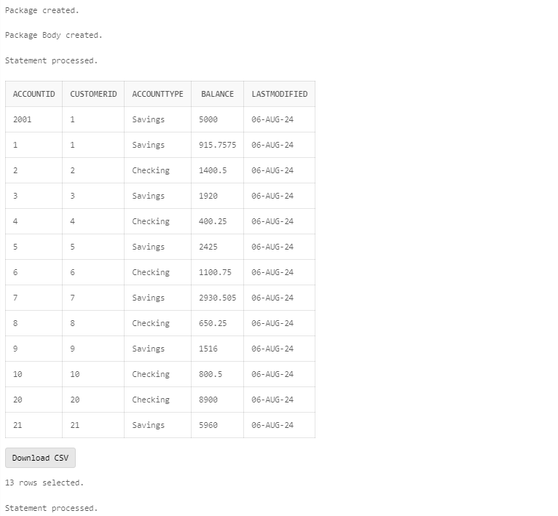

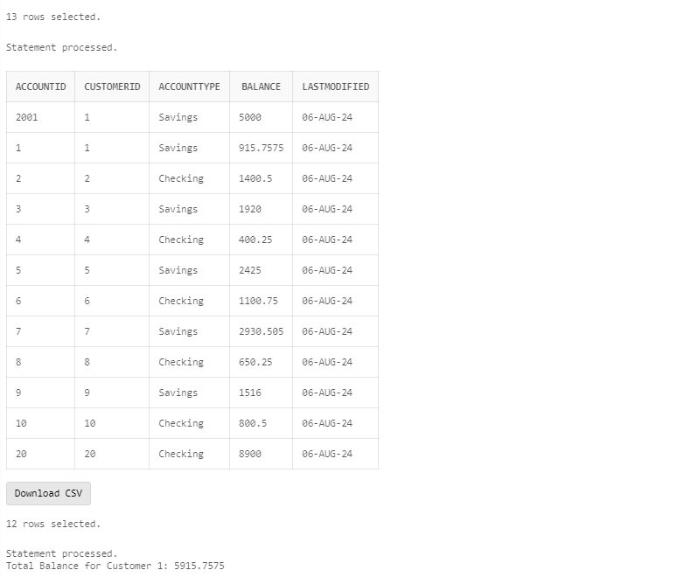

**Schema to be Created**

*CREATE TABLE Customers (*

*CustomerID NUMBER PRIMARY KEY,*

*Name VARCHAR2(100),*

*DOB DATE,*

*Balance NUMBER,*

*LastModified DATE*

*);*

*CREATE TABLE Account (*

*AccountID NUMBER PRIMARY KEY,*

*CustomerID NUMBER,*

*AccountType VARCHAR2(20),*

*Balance NUMBER,*

*LastModified DATE,*

*FOREIGN KEY (CustomerID) REFERENCES Customers(CustomerID)*

*);*

*CREATE TABLE Transactions (*

*TransactionID NUMBER PRIMARY KEY,*

*AccountID NUMBER,*

*TransactionDate DATE,*

*Amount NUMBER,*

*TransactionType VARCHAR2(10),*

*FOREIGN KEY (AccountID) REFERENCES Accounts(AccountID)*

*);*

*CREATE TABLE Loans (*

*LoanID NUMBER PRIMARY KEY,*

*CustomerID NUMBER,*

*LoanAmount NUMBER,*

*InterestRate NUMBER,*

*StartDate DATE,*

*EndDate DATE,*

*FOREIGN KEY (CustomerID) REFERENCES Customers(CustomerID)*

*);*

*CREATE TABLE Employees (*

*EmployeeID NUMBER PRIMARY KEY,*

*Name VARCHAR2(100),*

*Position VARCHAR2(50),*

*Salary NUMBER,*

*Department VARCHAR2(50),*

*HireDate DATE*

*);*

**Example Scripts for Sample Data Insertion**

*INSERT INTO Customers (CustomerID, Name, DOB, Balance, LastModified)*

*VALUES (1, 'John Doe', TO_DATE('1985-05-15', 'YYYY-MM-DD'), 1000, SYSDATE);*

*INSERT INTO Customers (CustomerID, Name, DOB, Balance, LastModified)*

*VALUES (2, 'Jane Smith', TO_DATE('1990-07-20', 'YYYY-MM-DD'), 1500, SYSDATE);*

*INSERT INTO Accounts (AccountID, CustomerID, AccountType, Balance, LastModified)*

*VALUES (1, 1, 'Savings', 1000, SYSDATE);*

*INSERT INTO Accounts (AccountID, CustomerID, AccountType, Balance, LastModified)*

*VALUES (2, 2, 'Checking', 1500, SYSDATE);*

*INSERT INTO Transactions (TransactionID, AccountID, TransactionDate, Amount, TransactionType)*

*VALUES (1, 1, SYSDATE, 200, 'Deposit');*

*INSERT INTO Transactions (TransactionID, AccountID, TransactionDate, Amount, TransactionType)*

*VALUES (2, 2, SYSDATE, 300, 'Withdrawal');*

*INSERT INTO Loans (LoanID, CustomerID, LoanAmount, InterestRate, StartDate, EndDate)*

*VALUES (1, 1, 5000, 5, SYSDATE, ADD_MONTHS(SYSDATE, 60));*

*INSERT INTO Employees (EmployeeID, Name, Position, Salary, Department, HireDate)*

*VALUES (1, 'Alice Johnson', 'Manager', 70000, 'HR', TO_DATE('2015-06-15', 'YYYY-MM-DD'));*

*INSERT INTO Employees (EmployeeID, Name, Position, Salary, Department, HireDate)*

*VALUES (2, 'Bob Brown', 'Developer', 60000, 'IT', TO_DATE('2017-03-20', 'YYYY-MM-DD'));*